
ENIGMA OPERATIONS
PROGRAMMING PROCEDURES
ENIGMA GENESIS
&
DEJAVU MEMORY ENHANCEMENT

Data input and feedback system
for Quantum DWAVE
computer
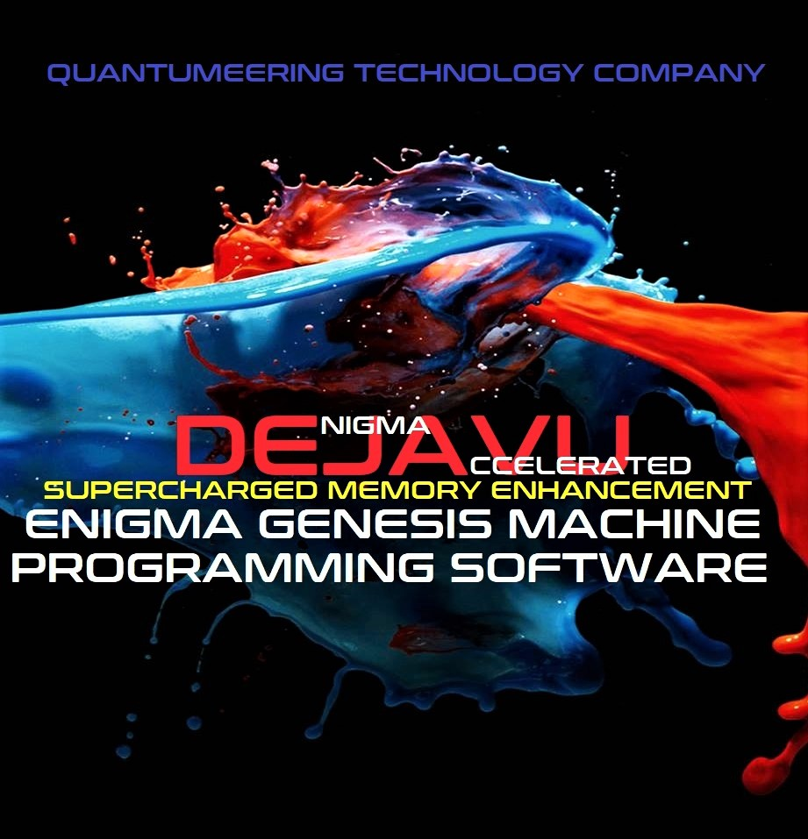
Phase One
GENESIS
GRAPHICS ENABLED NUMERICALLY ENGAGED SECURE INTERFACE SYSTEM

SYSTEM CATEGORIES; Pupil identification credential for initial system engagement. The basic qualifier for the initial phase one programming procedures will require the programmer to become authorized by the system via a facial recognition program accompanied by a pupil registry to be completed and uploaded into the system to ensure only authorized and cleared individuals can access the programming sequence of ENIGMA.

The eyepiece will use a Binocular pupil identification interface which will accomplish the task of photographing the programmers pupil features and verify against the registered record of the individual to activate the next phase of GENESIS.

The next step is to enter the authorization code which shall be a numerical code given by the host of the Quantum DWAVE System and will be derived by the governing authorities of the security department in charge of system security.

Upon proper authorization procedures aforementioned the GENESIS system will initiate the next step of uploading the ENIGMA program into the Data input Stream. Upon initial data upload to the system ENIGMA will do a self Scan and determine the Algorithmic Linear Logic Track to be utilized for the desired series of solution runs and once it has configured the most efficient track then it will begin to program the necessary algorithms to use voice commands from the programmer.

Depending on the scheduled time line of the required data solution run the system should take approximately ten to twenty minutes to run the test before actual programming can begin. The series of teaching lessons to be completed by the programmer will be divided into short interval runs to be increased as the machine learning curve improves and the proper feedback response is achieved. This will be determined by the data retrieved and implemented and enhanced by the DEJAVU system which will be running parallel to the ENIGMA program, although it will be acting as a moderator and language adjustment device on a codex level. In other words it will adapt and change the logic of the algorithms of ENIGMA to become more efficient and with less code as the system accelerates forward in it's beginning stage of Machine learning and memory intuitive development.

It is anticipated that the initial implementation of ENIGMA will cause a brief case of coded analytical overlay to develop within the Data input memory Bus however it is expected and will be dealt with as it develops. DEJAVU is designed to minimize the cause of this phenomena within the data stream of the ENIGMA structure as the OCTONIAN LIKE scaffolding will allow swift reordering of algorithms to facilitate a smooth programming sequence while the programmer will develop a sense of timing using vocal commands allowing the machine to develop an intuition response predictability and so further enhance the learning and retention of the system memory being created and stored within the ENIGMA software itself, which is a sort of AI separate from the Quantum memory data storage system.

The analytical overlay within the systems memory will be predicted and minimized to eliminate the amount of unanticipated assumptions by the system to program in error. Due to the nature of language input systems versus input of keyed in code, the chance for misunderstood language to be mistaken by the computer is a possibility initially, therefore the system has the language protocol interrupter feature within the DEJAVU software which will act as a library of words and synonyms and acronyms with a definitive code to ensure the correct meaning is established while the machine is learning. This will prevent it from learning the wrong meaning for a word or other vocalization.

After establishing a base of descriptive programming for the computer to utilize the vocal programming will become more efficient as the programming series becomes more advanced. As a child learns a new language so too must the computer develop a memory of words although it will be a virtual memory established and stored in the sub software of ENIGMA supplemented by DEJAVU this will become the foundational platform for future data solution runs.

This is the summary of the initial phase one programming procedures of ENIGMA and will be followed by Phase two.

The specific technical descriptions are reserved for a later discussion in more detail and will be found in the ENIGMA Technical manual which will accompany this manual.

LPIF ; Language Protocol Interrupter Feature:

The LPIF is a database of language protocols written as codex and is a full library of the English language and is set up to act as a programming interference device which will interact with the ENIGMA/DEJAVU STRAM and become an overseer of the algorithmic Assimilation and application to the data stream when words are spoken and the computer becomes stalled or slowed by incomprehension of the code versus the word spoken. This is anticipated and dealt with using this feature and will become a system of it's own which will self assimilate as the program becomes fully functional.
